MENU
- We cater for Small & big size (from 30-2000 people) parties.
- We design your choice menu & fit into your budget.

VEGITERIAN  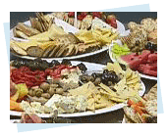 | NON VEGITERIAN  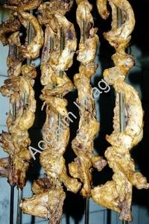
Veg. Soup | Non Veg. Soup
2 Veg starters | 2 Non veg. starters
Rice Pulao, Jeera Rice | Rice Pulao, Jeera Rice
Dal makhani or Dal Tadka | Dal makhani or Dal Tadka
1 Paneer base vegitable | 1 Paneer base vegitable
1 Seasonal Dry Mix vegitable | 1 Seasonal Dry Mix vegitable
 | Butter Chicken
Naan, Roti,Paratha,Rumali Roti, Chapati | Naan, Roti,Paratha,Rumali Roti, Chapati
Raita, Green Salad | Raita, Green Salad
Papad, Pickle | Papad, pickle
Hot stuffed Gulab jamun  Or  Dhudhi Halwa | Vanila Ice cream with Hot chocolate sauce  Or  Hot stuffed Gulabjamun

